**UMI DIAGRAM FOR PASSPORT MANAGEMENT SYSTEM**

**USE CASE DIAGRAM:**

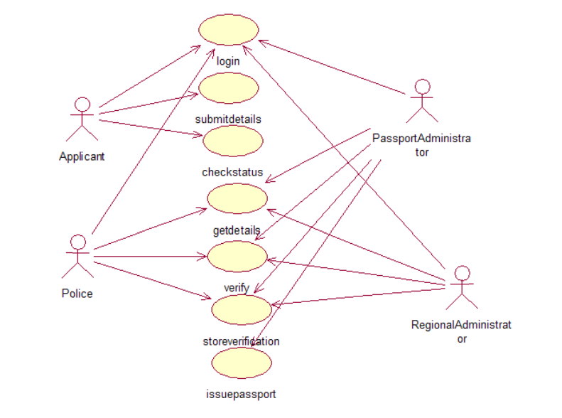

**CLASS DIAGRAM:**

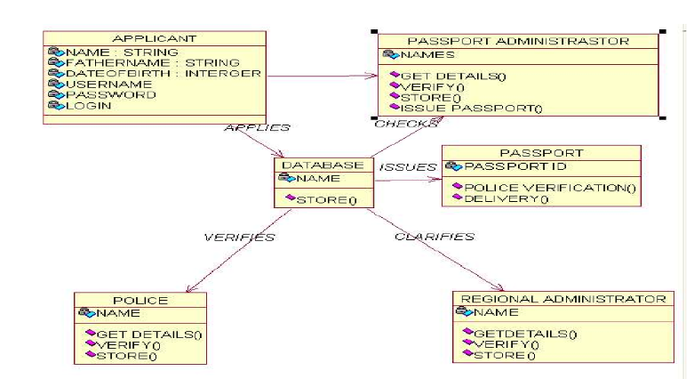

**ACTIVITY DIAGRAM:**

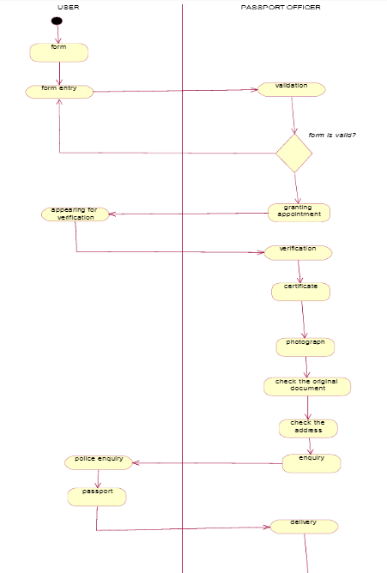

**SEQUENCE DIAGRAM:**

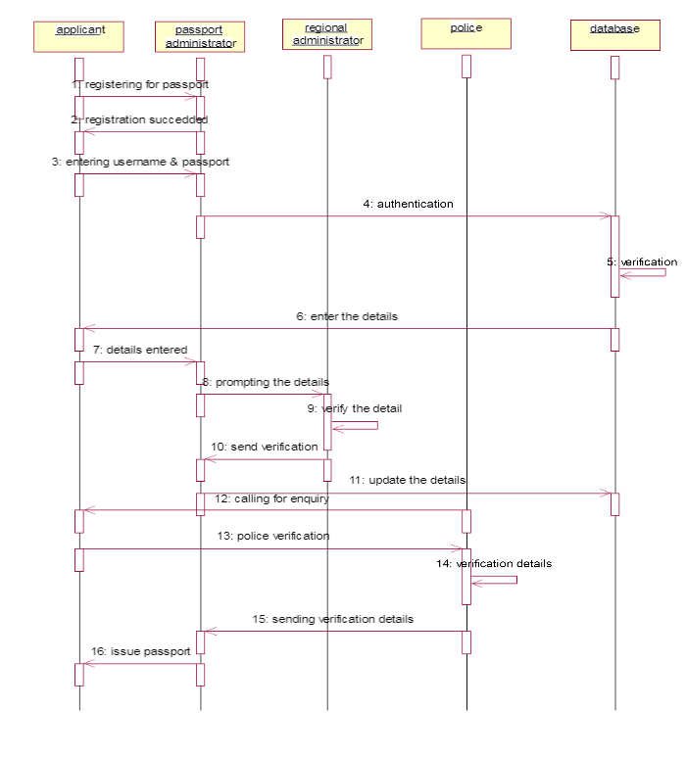

**COLLABRATION DIAGRAM:**

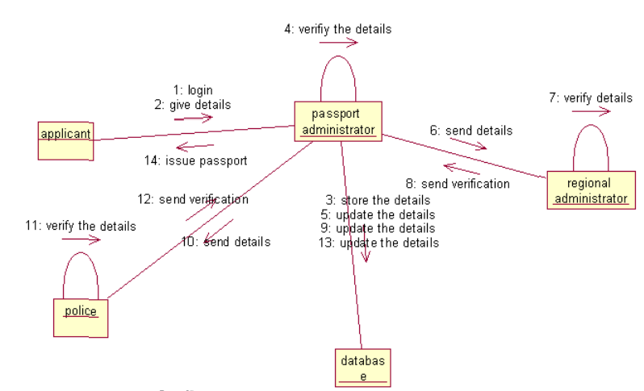

**COMPONENT DIAGRAM:**

